**Simple Linear Regression Theory**

**Regression:** used to find the relationship between variables.

**Linear Relation:** A linearrelation means that the change in one variable is directly proportional (or almost proportional) to the change in another variable.

**Linear Regression:** Used to find the relationship between 2 variables.

**Equation:** Y=β0 +β1X+ε

**Y:** Dependent variable

**X:** Independent variable

**Β1 (m):** Slope of the line (how much y changes for unit changes in x)

**Β0 (b):** Intercept (value of y when x is zero)

**ε:** Error Term

**Formula for β1:** sum of product of deviations/ sum of square of deviations for x

**Formula for β2:** Mean of Y - (β1 * mean of β1)

### **Assumptions of Linear Regression**

* Linear relationship between X and Y
* Residuals (errors) are normally distributed
* Homoscedasticity (equal variance of residuals)
* Independence of observations
* No/mild multicollinearity (Means predictors should be either not correlated or only weakly correlated with each other, not relevant for simple regression, but mention briefly)

### **How the Model Works**

* Goal: Find best fit line that minimizes error.
* **Ordinary Least Squares (OLS):** Ordinary Least Squares (OLS) is a method that finds the best-fit line by minimizing the total squared differences between actual and predicted values.

### **In Machine Learning**

* It’s the **foundation for regression problems**.
* Provides interpretability (easy to explain how X affects Y).
* Forms the base for more advanced algorithms like **Multiple Linear Regression, Logistic Regression, and Neural Networks**.

**Cost Function & Gradient Descent**

**Cost Function (aka Loss Function):** In linear regression, the cost function tells us how far off our predictions are from the actual values.

* **Formula For Cost Function:** 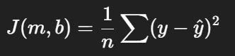
* Here, the first y value is the actual y value while the second is the y predicted value
* Cost should be reduced.
* If predictions are close to actual values → cost is low.
* If predictions are far → cost is high.

**Gradient descent:** algorithm that finds the best fit line for the given training data set.

* Start with random values of slope (*β1/m)* and intercept (*β0/b)*.
* Compute the gradient (slope of the cost function).
* Update the parameters step by step in the opposite direction of the gradient (downhill).
* ***Β1 (m):*** *m – learning_rate*m_derivative*
* ***Β0 (b):*** *b – learning_rate*b_derivative*
* ***B_derviative:*** -(2/n)*sum(y-y_predicted)
* ***m_derviative:*** -(2/n)*sum(x* (y-y_predicted))

**Key Intuition:**

* Think of cost function as a bowl-shaped curve.
* Gradient Descent is like a ball rolling down the bowl until it reaches the bottom (minimum cost).
* The bottom point corresponds to the best values of β₀ and β₁ → best-fit line.

**Key Takeaways:**

* Cost Function measures prediction error.
* Gradient Descent minimizes that error step by step.
* Learning rate (*α\alpha*) is crucial:
* Too small → very slow.
* Too large → may overshoot and never converge.

**Multiple Linear Regression**

**Regression:** used to find the relationship between variables.

**Multiple Linear Regression:** This relation will have multiple independent variables and 1 dependent variables.

**Formula:** *Y=β0 +β1 X1 +β2 X2 +⋯+βn Xn +ϵ*

**Finding values of coefficients:**

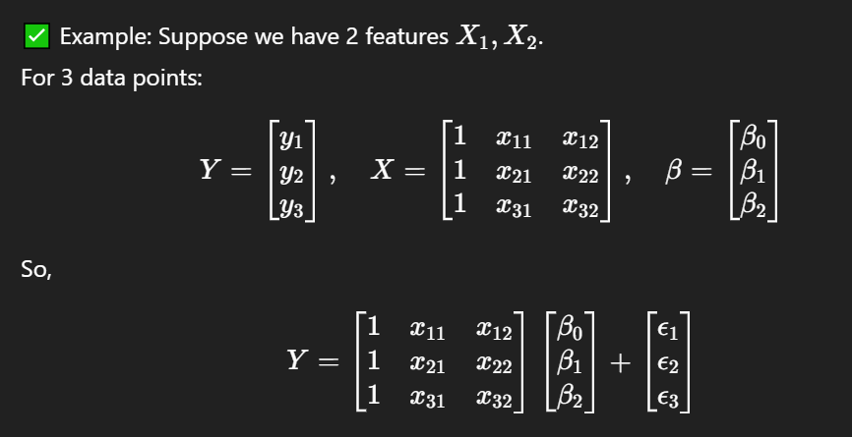

**Formula to find coefficients:**

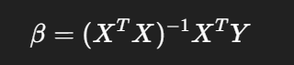

**Why do we use it?**

* To predict outcomes using multiple factors.
* To understand relationships between variables.
* To identify which variables, matter most.

**Polynomial Regression**

**Regression:** used to find the relationship between variables.

**Multiple Linear Regression:** This relation will have multiple independent variables and 1 dependent variables.

**Formula:** *Y=β0 +β1 X1 +β2 X2 +⋯+βn Xn +ϵ*

**Finding values of coefficients:**